Short Hotel Booking Website
A very short hotel booking page (about 30 lines). It searches hotels by destination, dates and guests, shows price, amenities and review, lets you log in by name, pay with a 16-digit card number (simulated) and see your bookings.
Note: payment and confirmation email are simulated.

Output
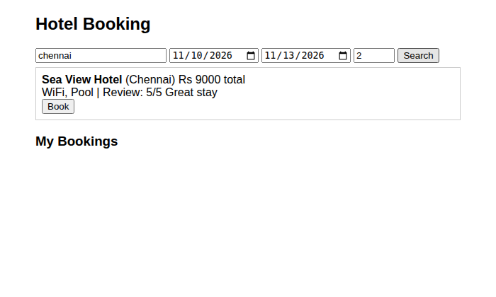
Figure 1: Search results for Chennai
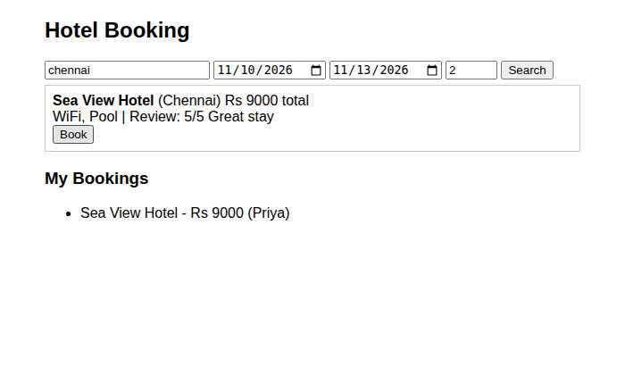
Figure 2: Booking done, shown under My Bookings

Code (hotel_short.html)
<!DOCTYPE html>
<html><head><title>Hotel Booking</title>
<style>body{font-family:Arial;max-width:600px;margin:20px auto}.h{border:1px solid #ccc;padding:8px;margin:6px 0}</style></head>
<body>
<h2>Hotel Booking</h2>
<input id="d" placeholder="Destination"> <input id="i" type="date"> <input id="o" type="date">
<input id="g" type="number" value="2" style="width:50px"> <button onclick="find()">Search</button>
<div id="list"></div>
<h3>My Bookings</h3><ul id="my"></ul>
<script>
var user = "", mine = [];
var hotels = [
{ n: "Sea View Hotel", c: "Chennai", p: 3000, max: 3, a: "WiFi, Pool", r: "5/5 Great stay" },
{ n: "Beach Palm Resort", c: "Goa", p: 4500, max: 4, a: "WiFi, Spa", r: "4/5 Lovely beach" }];
function find() {
var nights = (new Date(o.value) - new Date(i.value)) / 86400000, h = "";
if (!(nights > 0)) return alert("Choose valid dates");
hotels.forEach(function (x, k) {
if (x.c.toLowerCase().indexOf(d.value.toLowerCase()) < 0 || x.max < g.value) return;
h += "<div class='h'><b>" + x.n + "</b> (" + x.c + ") Rs " + x.p * nights + " total<br>" + x.a +
" | Review: " + x.r + "<br><button onclick='book(" + k + "," + nights + ")'>Book</button></div>";
});
list.innerHTML = h || "No hotels found";
}
function book(k, n) {
user = user || prompt("Login: enter your name");
if (user && prompt("Enter 16 digit card number").length == 16) {
mine.push(hotels[k].n + " - Rs " + hotels[k].p * n + " (" + user + ")");
my.innerHTML = "<li>" + mine.join("</li><li>") + "</li>"; alert("Payment done. Confirmation sent!");
}
}
</script></body></html>

